**OBSTACLE AVOIDING ROBOT APROJECTREPORT**



***Submittedby***

#### RUTHRESH J 22CS138 RUDHRESH S 22CS137

***in partial fulfilment for award of the degree of***

#### BACHELOR OF ENGINEERING

***in***

**COMPUTER SCIENCE AND ENGINEERING CHENNAI INSTITUTE OF TECHNOLOGY**

**CHENNAI 600069**

**ANNA UNIVERSITY CHENNAI 600025**

**OCTOBER 2023**

**BONAFIDECERTIFICATE**

Certifiedthatthisproject**“OBSTACLE AVOIDING ROBOT”**isthebonafideworkof**“RUDHRESH S (22CS137) & RUTHRESH J (22CS138)”**who carried outtheproject workunder mysupervision.

**SIGNATURE OF SIGNATUREOFHEADOFTHE**

**SUPERVISOR DEPARTMENT**

**Ms. K. P. ASWATHI,M.E., Dr. S. PAVITHRA, M.E., Ph.D.,**

AssistantProfessor Professorand Head

Department of Computer Science and Department of Computer Science and Engineering, Engineering,

Chennai Institute of Technology, Chennai Institute Of Technology, Kundrathur–600069. Kundrathur–600069.

**Submitted for the viva-voice held onTechnology,Kundrathur.**

**atChennaiInstituteof**

**INTERNALEXAMINER EXTERNALEXAMINER**

**ACKNOWLEDGEMENT**

We thank our beloved **Chairman Shri. P. SRIRAM** and all the trust members ofChennai Institute of Technology at this high time for providing us with a plethora offacilitiestocompletemyprojectsuccessfully.

We take the privilege to express my thanks to our Principal **Dr A. RAMESH, M.E.,Ph.D.,**whohasbeenabastionofmoralstrengthandasourceofincessantencourageme nttous.

We express our sincere thanks to **Dr. S.PAVITHRA, M.E., Ph.D.,** Project Guide andProject Supervisor **Mr. K . P . ASWATHI, M.E.,** . We take immense pleasure to have them also as our mentor providing valuable suggestions, excellent guidance,andconstantsupportallthroughthecourse ofourproject.

Wealsothanktheteachingandnon-teachingstaffmembersoftheInformationTechnology Department and all our fellow students who stood with us to completeour project successfully. Finally, we extend our deep gratitude to our beloved familymembers for their moral coordination, encouragement, and financial support to carryoutthis project

#### ABSTRACT

Obstacle avoidance is one of the most important aspects of mobile robotics. Without it, robot movement would be very restrictive and fragile. This project proposes robotic vehicle that has an intelligence built in it such that it directs itself whenever an obstacle comes in its path. So, to protect the robot from any physical damages. This can be design to build an obstacle avoidance robotic vehicle using ultrasonic sensors for its movement. A micro-controller (AT mega 328P) is used to achieve the desired operation. An ultrasonic sensor is used to detect any obstacle ahead of it and sends a command to the micro- controller. Depending on the input signal received, the micro-controller redirects the robot to move in an alternate direction by actuating the motors which are interfaced to it through a motor driver.

|  |  |  |
| --- | --- | --- |
|  | **TABLEOFCONTENTS** |  |
| **CHAPTER** | **TITLE** | **PAGE NO** |
|  | **ABSTRACT** | 2 |
|  | **LISTOFFIGURES** | 4 |
| **1** | **INTRODUCTION** | 5 |
| **2** | **LITERATUREREVIEW** | 6 |
| **3** | **HARDWARECOMPONENTS** | 8 |
|  | **3.1.**ArduinoUno | 8 |
|  | **3.2.**UltrasonicSensorModule | 9 |
|  | **3.3.**Servo Motor | 9 |
|  | **3.4**.JumperWires | 10 |
|  | **3.5**. L293DMotor Driver Shield | 11 |
|  | **3.6.**DC motor | 12 |
|  | **3.7**Obstacle Avoiding Robot | 12 |
| **4** | **SOFTWAREREQUIREMENTS** | 13 |
|  | **4.1.**ArduinoIDESetup | 13 |
| **5** | **METHODOLOGY** | 14 |
|  | **5.1.**BlockDaigram | 14 |
|  | **5.2.**Configurationwithcomponents | 16 |

usingcode

**6 CONCLUSIONANDFUTURE WORK** 17

**LISTOFFIGURES**

|  |  |  |
| --- | --- | --- |
| **FIGURENO** | **NAMEOFTHEFIGURE** | **PAGENO** |
| 3.1 | ArduinoUno | 8 |
| 3.2 | UltrasonicSensor | 9 |
| 3.3 | ServoMotor | 10 |
| 3.4 | Male toMaleJumperWires | 10 |
| 3.5 | L293DMotor Driver Shield | 12 |
| 3.6  3.7 | DC Motor  Obstacle Avoiding Robot | 13  13 |
| 5.1 | BlockDiagram | 15 |

**Chapter1**

# Introduction

* Robotics is part of Todays communication. In today's world ROBOTICS is fast growing and interesting field. It is simplest way for latest technology modification. Now a days communication is part of advancement of technology, so we decided to work on ROBOTICS field, and design something which will make human life simpler in day today aspect. Thus we are supporting this cause.
* An obstacle avoiding robot is an intelligent device, which can automatically sense and overcome obstacles on its path. Obstacle Avoidance is a robotic discipline with the objective of moving vehicles on the basis of the sensorial information. The use of these methods front to classic methods (path planning) is a natural alternative when the scenario is dynamic with an unpredictable behaviour. In these cases, the surroundings do not remain invariable, and thus the sensory information is used to detect the changes consequently adapting moving. It will automatically scan the surrounding for further path.
* This project is basic stage of any automatic robot. This ROBOT has sufficient intelligence to cover the maximum area of provided space. It has a ultrasonic sensor which are used to sense the obstacles coming in between the path of ROBOT. It will move in a particular direction and avoid the obstack which is coming in its path. We have used two D.C motors to give motion to the ROBOT. The construction of the ROBOT circuit is easy and small The electronics parts used in the ROBOT circuits are easily available and cheap too
  1. **InternetOfThins:**

## Chapter 2 Literature Review

(INTERNATIONAL;JOURNALOFCOMMUNICATIONSYSTEM)

byFengXia,Laurence

We are witnessing the dawn of a new era of internet of things alsoknown as internet of objects. generally speaking, IOT refers to the networkedinterconnection of everyday objects, which are often equipped with ubiquitousintelligence. Iot will increase the ubiquity of the internet by interrelating everyobject for integration via embedded system which leads to a highly distributednetwork of a device. Thanks it rapid advances in underlying technologies. Iot isopening tremendous opportunities for a large number of novel application thatpromisesto improvethequality ofourlives.

In recent years, IOT has gained much attention from researches andpractitionersfromaround world.

##### Iot based obstacle detection:

We reviewed different obstacle detecting robot mechanisms that have been built by a lot of students and other practitioners that are in existence. For an autonomous mobile robot performing a navigation- based task in a vague environment, to detect and to avoid encountered obstacles is an important issue and a key function for the robot body safety as well as for the task continuity. Obstacle detection and avoidance in a real world environment that appears so easy to humans is a rather difficult task for autonomous mobile robots and is still a well- researched topic in robotics. In many previous works, a wide range of sensors and various methods for detecting and avoiding obstacles for mobile robot purpose have been proposed. Good

**Chapter3**

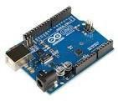

# HardwareComponents

##### To make a odstacle avoiding robot components we need is:

* + ArduinoUno
  + UltrasonicSensor Module
  + MotorDriverIC
  + JumperWires
  + Servomotor
  + L293DMotor Driver Shield
  + DC Motor

##### ArduinoUno:

Arduino Uno is a versatile and widely used microcontroller board designed for amyriadofelectronicsprojectsandprototypingapplications.Atitscore,itfeaturest heAtmelATmega328Pmicrocontroller,boasting14digitalinput/outputpins,6of whichcanproducepulse-widthmodulation(PWM)signals, and 6 analog input pins for reading varying voltage levels. With a clockspeed of 16 MHz and ample memory (32 KB flash, 2 KB SRAM, and 1 KBEEPROM)

Fig.3.1Arduino uno

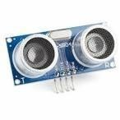

##### UltrasonicSensorModule:

An ultrasonic sensor module is a versatile device widely used invariousapplications,employingultrasonicwavestomeasuredistancesanddetect the presence of objects. Its operation relies on the transmission of high- frequency ultrasonic pulses, typically at 40 kHz, which bounce off objects andare receivedby abuilt-in sensor.

They find applicationinr obotics for obstacle avoidance, parking assistance in vehicles, levelsensingin tanks,security systems, and more. However, challenges such as reflections, limited range in certain conditions, and potentialmultipathin terference need to beconsid ered during their deployment.

Ultrasonic sensor modules are often integrated with microcontrollerplatforms like Arduino and single-board computers like RaspberryPi to create interactive and intelligentsystems, and on going advancement sinsensor technology continueto expand their capabilities.

Fig:3.2.UltrasonicSensor

## ServoMotor:

Servomotors are pivotal components in there almofrobotics

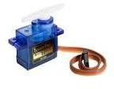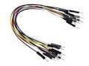

,automation,andmechatronics,knownfortheirprecisionandversatilityincontrolling angularor linearmotion.

These motors are fundamentally different from typical DC motorsastheyencompassaclosed- loopcontrolsystem.Atypicalservomotorcomprisesseveralkeyelements:aDCmotor, afeedbacksensor(usuallyapotentiometer orencoder),and acontrolcircuit.

Fig:3.3.ServoMotor

## MaleToMaleJumperWirers:

Male-to-male jumper wiresare essential components in electronics and prototypingprojects.These wires consist of connectorsatbothends,typically I n the form of male pins or pins with exposed metal tips.

Fig:3.4MaletoMaleJumperWires

They areused to establishelectrical connectionsbetween various componentson a breadboard, PCB, or other electronic platforms. One end of the wire can beeasily plugged into header pins, sockets, or other female connectors, while theotherendcansimilarlyconnecttomalepinsorcomponentslikesensors,microcontr ollers, orotherelectronicmodules.

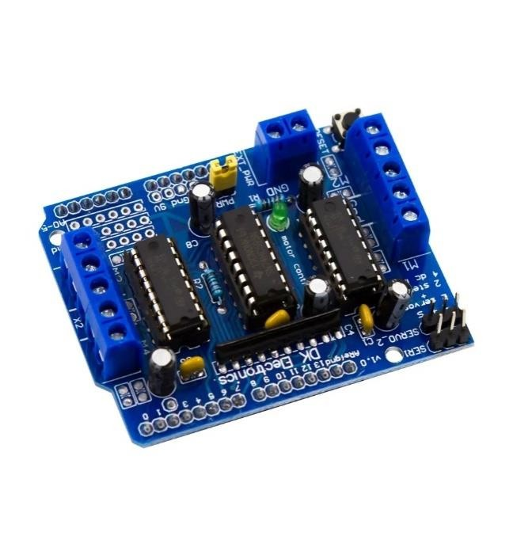

## L293DMotor Driver Shield:

### The motors typically cannot be driven directly by Arduino or another microcontroller. This is because of their higher current and power ratings, so motor shields or driver ICs are used instead. These shields or ICs isolate a motor’s power supply and use control logic from the microcontroller circuitry.

The full-featured L293D motor driver shield can control up to four bi-directional DC motors with 8-bit sp

Fig:3.5L293DMotor Driver Shield

## DC Motor

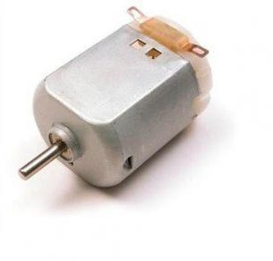

### A DC motor is an electrical motor that uses direct current (DC) to produce mechanical force. The most common types rely on magnetic forces produced by currents in the coils. Nearly all types of DC motors have some internal mechanism, either electromechanical or electronic, to periodically change the direction of current in part of the motor.

Fig 3.6 DC Motor

* 1. **OBSTACLE AVOIDING ROBOT**

### Obstacle Avoiding Robot is an intelligent device that can automatically sense the obstacle in front of it and avoid them by turning itself in another direction. This design allows the robot to navigate in an unknown environment by avoiding collisions, which is a primary requirement for any autonomous mobile robot.

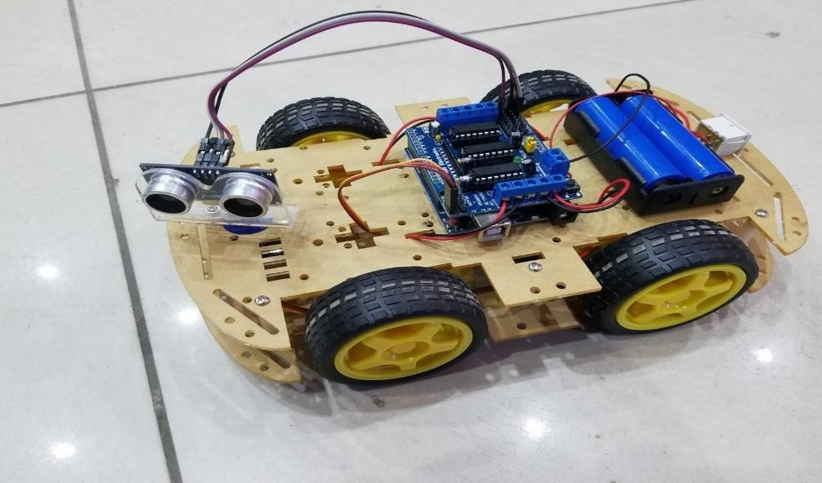

Fig:3.7OBSTACLE AVOIDINGROBOT

# Chapter 4 Softwere requirements

## ArduinoIDEsetup:

* + 1. DownloadArduinoIDE:
* VisittheofficialArduinowebsiteathttps://[www.arduino.cc/en/software.](http://www.arduino.cc/en/software)
* Clickon the"DownloadtheArduinoIDE"buttonforWindows.
* Downloadtheinstallertoyour computer.
  + 1. RuntheInstaller:
* Locatethedownloadedinstallerfile(e.g.,"arduino-x.x.x-windows.exe").
* Double-clicktheinstallertorun it.
* Ifpromptedforadministrativepermissions,grantthem.
  + 1. InstallationWizard:
* Followtheon-screeninstructionsintheinstallationwizard.
* Youcanleavemostsettingsattheirdefaultvalues.
  + 1. DriverInstallation(ifneeded):
* Duringtheinstallation,youmaybepromptedtoinstalldriversforArduino boards.Followthepromptstocompletethisstep.
  + 1. CompleteInstallation:
* Oncetheinstallationiscomplete,clickthe"Close" button

**Chapter5**

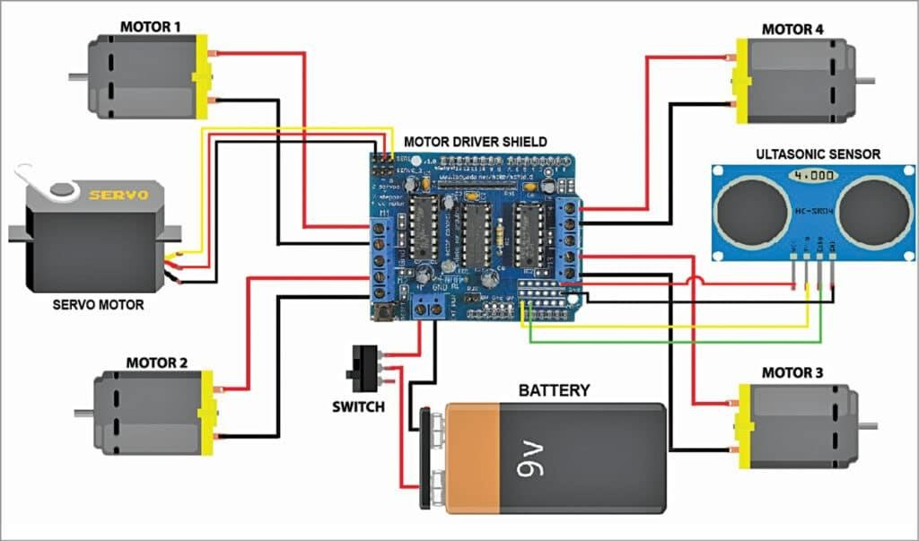

# Methodology

##### BlockDaigram:

* 1. **Configuration with components using code:**

**#include<Servo.h> #include<NewPing.h> #include<AFMotor.h>**

**#define TRIG_PIN A0; #define ECHO_PIN A1;**

**#define MAX_DISTANCE 300;**

**#define COOLIDE_DIST 30;**

**#define MAX_SPEED 160;**

**#define MAX_SPEED_OFFSET 40;**

**AF_DCMotor LEFTMOTOR1(1,MOTOR12_1KHZ); AF_DCMotor LEFTMOTOR2(2,MOTOR12_1KHZ);**

**AF_DCMotor RIGHTMOTOR1(3,MOTOR12_1KHZ); AF_DCMotor RIGHTMOTOR2(4,MOTOR12_1KHZ);**

**Servo myservo;**

**NewPing sonar(TRIG_PIN,ECHO_PIN,MAX_DISTANCE); int CURR_DIST=0;**

**int LEFTDISTANCE,RIGHTDISTANCE;**

**void setup()**

**{**

**myservo.attach(10); myservo.write(90); delay(1000);**

**}**

**void loop()**

**{**

**myservo.write(90); delay(90); CURR_DIST=readPing();**

**if(CURR_DIST<COLLIDE_DIST)**

**{**

**changePath();**

**}**

**moveForward(); delay(500);**

**}**

**void changePath()**

**{**

**moveStop(); myservo.write(36); delay(500);**

**RIGHTDISTANCE=readPing();**

**delay(500); myservo.write(144); delay(500); LEFTDISTANCE=readPing();**

**delay(500);**

**myservo.write(90); compareDistance();**

**}**

**void compareDistance(){ if(LEFTDISTANCE>RIGHTDISTANCE){**

**turnLeft();**

**}**

**else if(RIGHTDISTANCE>LEFTDISTANCE){**

**turnRight();**

**}**

**else{ turnAround();**

**}**

**}**

**void readPing()**

**{**

**delay(70);**

**unsigned int us=sonar.ping();**

**int cm=us/US_ROUNDTRIP_CM; return cm;**

**}**

**Chapter6**

# Conclusionand Future Work

**Conclusion:**

The goal of our project is to create a autonomous robot which

intelligently detects the obstacle in his path and navigate according to the actions we set for it. The above Arduino controller and ultrasonic sensor were studied and the HcSR-04 ultrasonic sensor was selected, as the controlling result are satisfying for its use in the automobile prototype system bring developed. It was used to sense the obstacle and avoidance them. On successful implementation of obstacle avoidance algorithm was successfully carried out too with minimal errors, by coding the algorithm in python. Obstacle avoidance is a very good application to be used in vehicle preventing many accidents and loss of life. This project developed an obstacle avoiding robot to detect and avoid obstacles in its path. The robot is built on the Arduino platform for data processing and its software counterpart helped to communicate with the robot to send parameters for guiding movement. For obstacle detection, three ultrasonic distance sensors were used that provided a wider field of detection. The robot is fully autonomous and after the initial loading of the code, it requires no user intervention during its operation. When placed in unknown environment with obstacles, it moved while avoiding all obstacles with considerable accuracy. In order to optimize the movement of the robot, we have many considerations for improvement. However, most of these ideas will cost more money and time as well. In future cameras can be used to detect the obstacle however, it is better to get CCD or industrial use ones to get clear and fast pictures. Even the ones we mentioned in the camera holder part will be better because of the special software.

|  |  |
| --- | --- |
| **APPLICATIONS** |  |
| * This device has application in surveying different landscapes and mapping them. It can also be used in commercial devices like * Automated lawn mover * Smart room cleaner etc * Obstacle avoiding robots can be used in almost all mobile robot navigation systems. * They can also be used in dangerous environments, where human penetration could be fatal * Unmanned vehicle driving * Mining Vehicle that uses Obstacle Detection   22 | |